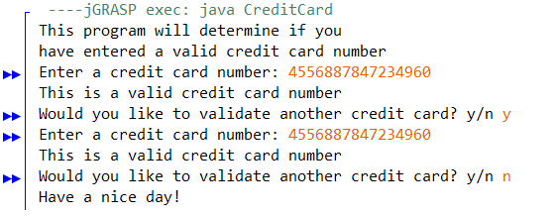
CreditCard
run
lengthValidation
prefixDigitValidation
sumOfOddPlaced
sumOfEvenPlaced
sumOfDoubleDigit
isValid

- CreditCard
- Run
  - Uses the previous methods and displays the text of the program
- sumOfOdd/Even/DoubleDigit
  - Finds the sum of the numbers in the odds and evens place
  - Finds the sum of two digit numbers (17 = 1 + 7 = 8)
- length/prefixDigitValidation
  - Validates the length of the number as well as making sure the digits are only 0-9

